CURRICULAM VITAE

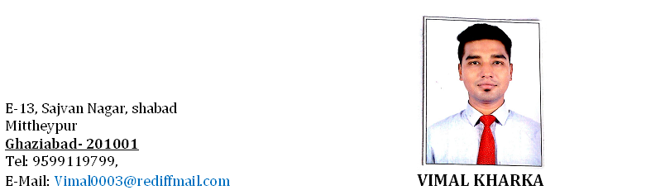

JOB OBJECTIVE

Seeking an opportunity to work in professional environment which utilizes my technical skill, innovative abilities, and interpersonal skills and provides me with versatile and challenging responsibilities.

EDUCATIONAL QUALIFICATIONS
.
- Intermediate from Commerce Stream & Examination Board of C.B.S.E From 2008
- Matriculation Examination Board of C.B.S.E From 2006

PROFESSIONAL QUALIFICATIONS

- 3 year B.Sc in Hospitality and Catering Management from CHM 2009-2012 College of Hotel and Business Management, Ghaziabad (Affiliated from SIKKIM MANIPAL UNIVERSITY).

- Industrial training from “RAMADA by prime” JAIPUR 2010 (RAJ).
- O.T with “THE WESTIN SOHNA” Resort, Gurgaon 2009.

PRESENT WORK EXPERIANCE

- Currently working with Royal Caribbean International at Miami, Florida (USA) in Culinary department since 17th January 2016 up to till date as a “COMMIS-2” Cruises Name :Freedom of the Seas.

PREVIOUS WORK EXPERIENCE

- Worked as an Asst. Cook at “ABU DABI NATIONAL HOTEL” Compass (ADNH), Dubai (U.A.E) from 12/11/2013 to 09/11/2014(LIVE COOK).
- Worked as an Asst. Cook at CHIL’S RESTAURANT SAKET from November 2015 to December 2015

LANGUAGE SKILL

- IELTS Score- 6

THE KEY RESULT AREAS

- Handling the Indian & cold section operations.
- Do all the required miss-e-place for all meals .
- Maintain clean as go as the work completes.
- Ensuring all set standards for preparing meals.
- Ensure all meals are cooked with hygiene and till required temperature.
- Assisting the head cook for preparing all meals with set standards.
- Take care of all required materials to run the operation in an smooth manner.
- Prepare all meals for live station
- Cook all meals in live station as per set standards.

PERSONAL DETAILS

Father’s Name : Mr. Bir Bahadur Kharka
Date of Birth : 12th Feb 1990
Language : English &Hindi
Marital Status : Married
Hobbies : Cooking, Reading, and listening Music.

ABILITY AND STRENGTH

I am creative and active person and a quick learner; persist to chase the goal in adverse circumstance. Having culinary skill and knowledge of hot and cold kitchen.

Date:

Place: Ghaziabad ( VIMAL KHARKA)

